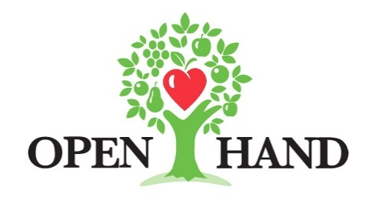

More Information:
Brianna Poplaskie
BRAVE Public Relations
404.233.3993
bpoplaskie@emailbrave.com
FOR IMMEDIATE RELEASE

Open Hand Atlanta raises more than $127,000 during 2022 “Dining Out For Life” annual fundraiser
Nonprofit provides healthy meals and nutrition education to individuals struggling with chronic illnesses and food insecurities
ATLANTA (July 29, 2022) – Open Hand Atlanta and presenting sponsor Subaru are honored to announce that over $127,000 was raised during the 29th annual Dining Out For Life benefit event, which was held on April 27, 2022. The annual event saw the city dine out at well-known restaurants from all over the Metro Atlanta area to benefit the non-profit. One of the largest city-wide fundraisers of the year, proceeds from Dining Out For Life help Open Hand Atlanta and its thousands of volunteers provide nearly 5,000 nutritious meals daily and support their neighbors battling chronic disease and disability to live healthier, more independent lives.

Dining Out For Life is an international event that occurs annually throughout 60 cities worldwide. While dining out for breakfast, lunch and dinner in Atlanta, guests were able to choose from a list of more than 80 participating restaurants. In return, the restaurants donated a portion of each customer’s total bill to Open Hand Atlanta. This year’s restaurants included Atlanta favorites, such as Guac y Margy’s, The General Muir, Local Three, Max Lager’s and Agave.

On September 29, Open Hand Atlanta’s annual benefit Party in the Kitchen will return for its 19th year. Hosted in The Stave Room at American Spirit Works, this formal fundraising event will engage guests with an elegant night of live and silent auctions, music and delicious bites and cocktails from some of Atlanta’s best restaurants, with all proceeds benefiting the organization.

For more information on Dining Out For Life and Open Hand Atlanta, as well as events and volunteer opportunities, please visit diningoutforoh.org and openhandatlanta.org or connect via Facebook, Twitter and Instagram.

ABOUT OPEN HAND ATLANTA:
Open Hand Atlanta is one of the largest community-based providers of home-delivered meals and nutrition services in the U.S. Founded in 1988, the nonprofit delivers delicious, nourishing meals and nutrition education to thousands of seniors, children and families, and our neighbors who are at risk for or have a disability or illness. In 2021, Open Hand cooked nearly 1.5 million made-from-scratch meals that promote health and are approved by a registered dietitian before they are delivered directly to clients’ homes. With custom menus to address specific health conditions, all Open Hand meals meet or exceed the most rigorous nutritional standards set by the American Diabetes Association, the USDA, and the American Heart Association. Learn more at openhandatlanta.org.

###

